Literacy support worksheet

9.1 The Earth, Sun and Moon interact with each other

Pages 156–157 and 211

Earth, Sun and Moon interactions

1 Without the Sun we could not survive.

a What is the Sun?

b Describe what is the Sun is like.

c What does the Sun provide for the Earth?

2 To explain why the Earth experiences daytime and night-time, label the diagram below with the words *axis*, *equator*, *North pole* and *South pole.* In addition, include an arrow to show the direction of rotation and the Sun’s rays.

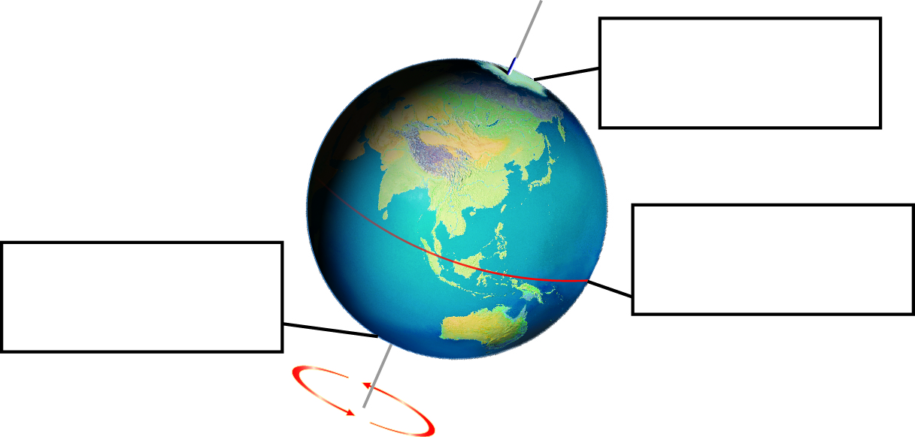

3 At the equator, the world rotates at 1670 kilometres per hour. How many kilometres would it travel in:

a one minute? _____________________________________________________________

b one day? _____________________________________________________________

c one non-leap year? _____________________________________________________________

4 The diagrams below show the position of the Sun, Earth and Moon during a solar and lunar (Moon) eclipse.

a What is the position of the Moon during a solar eclipse?

b What is the position of the Moon during a lunar eclipse?

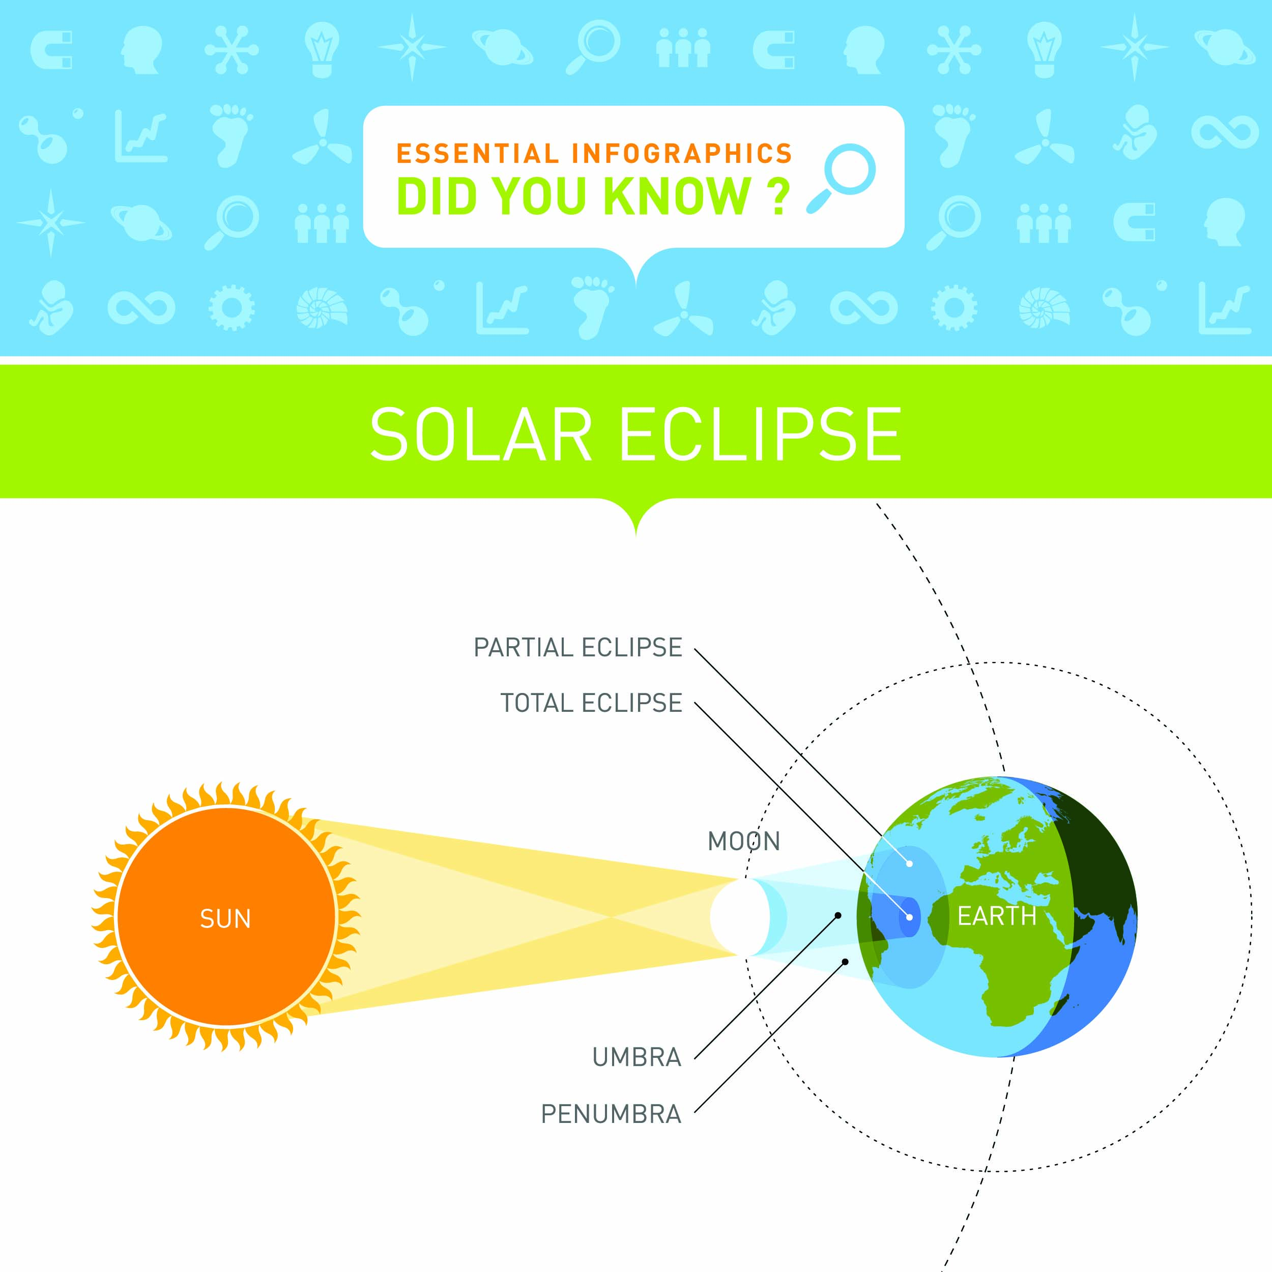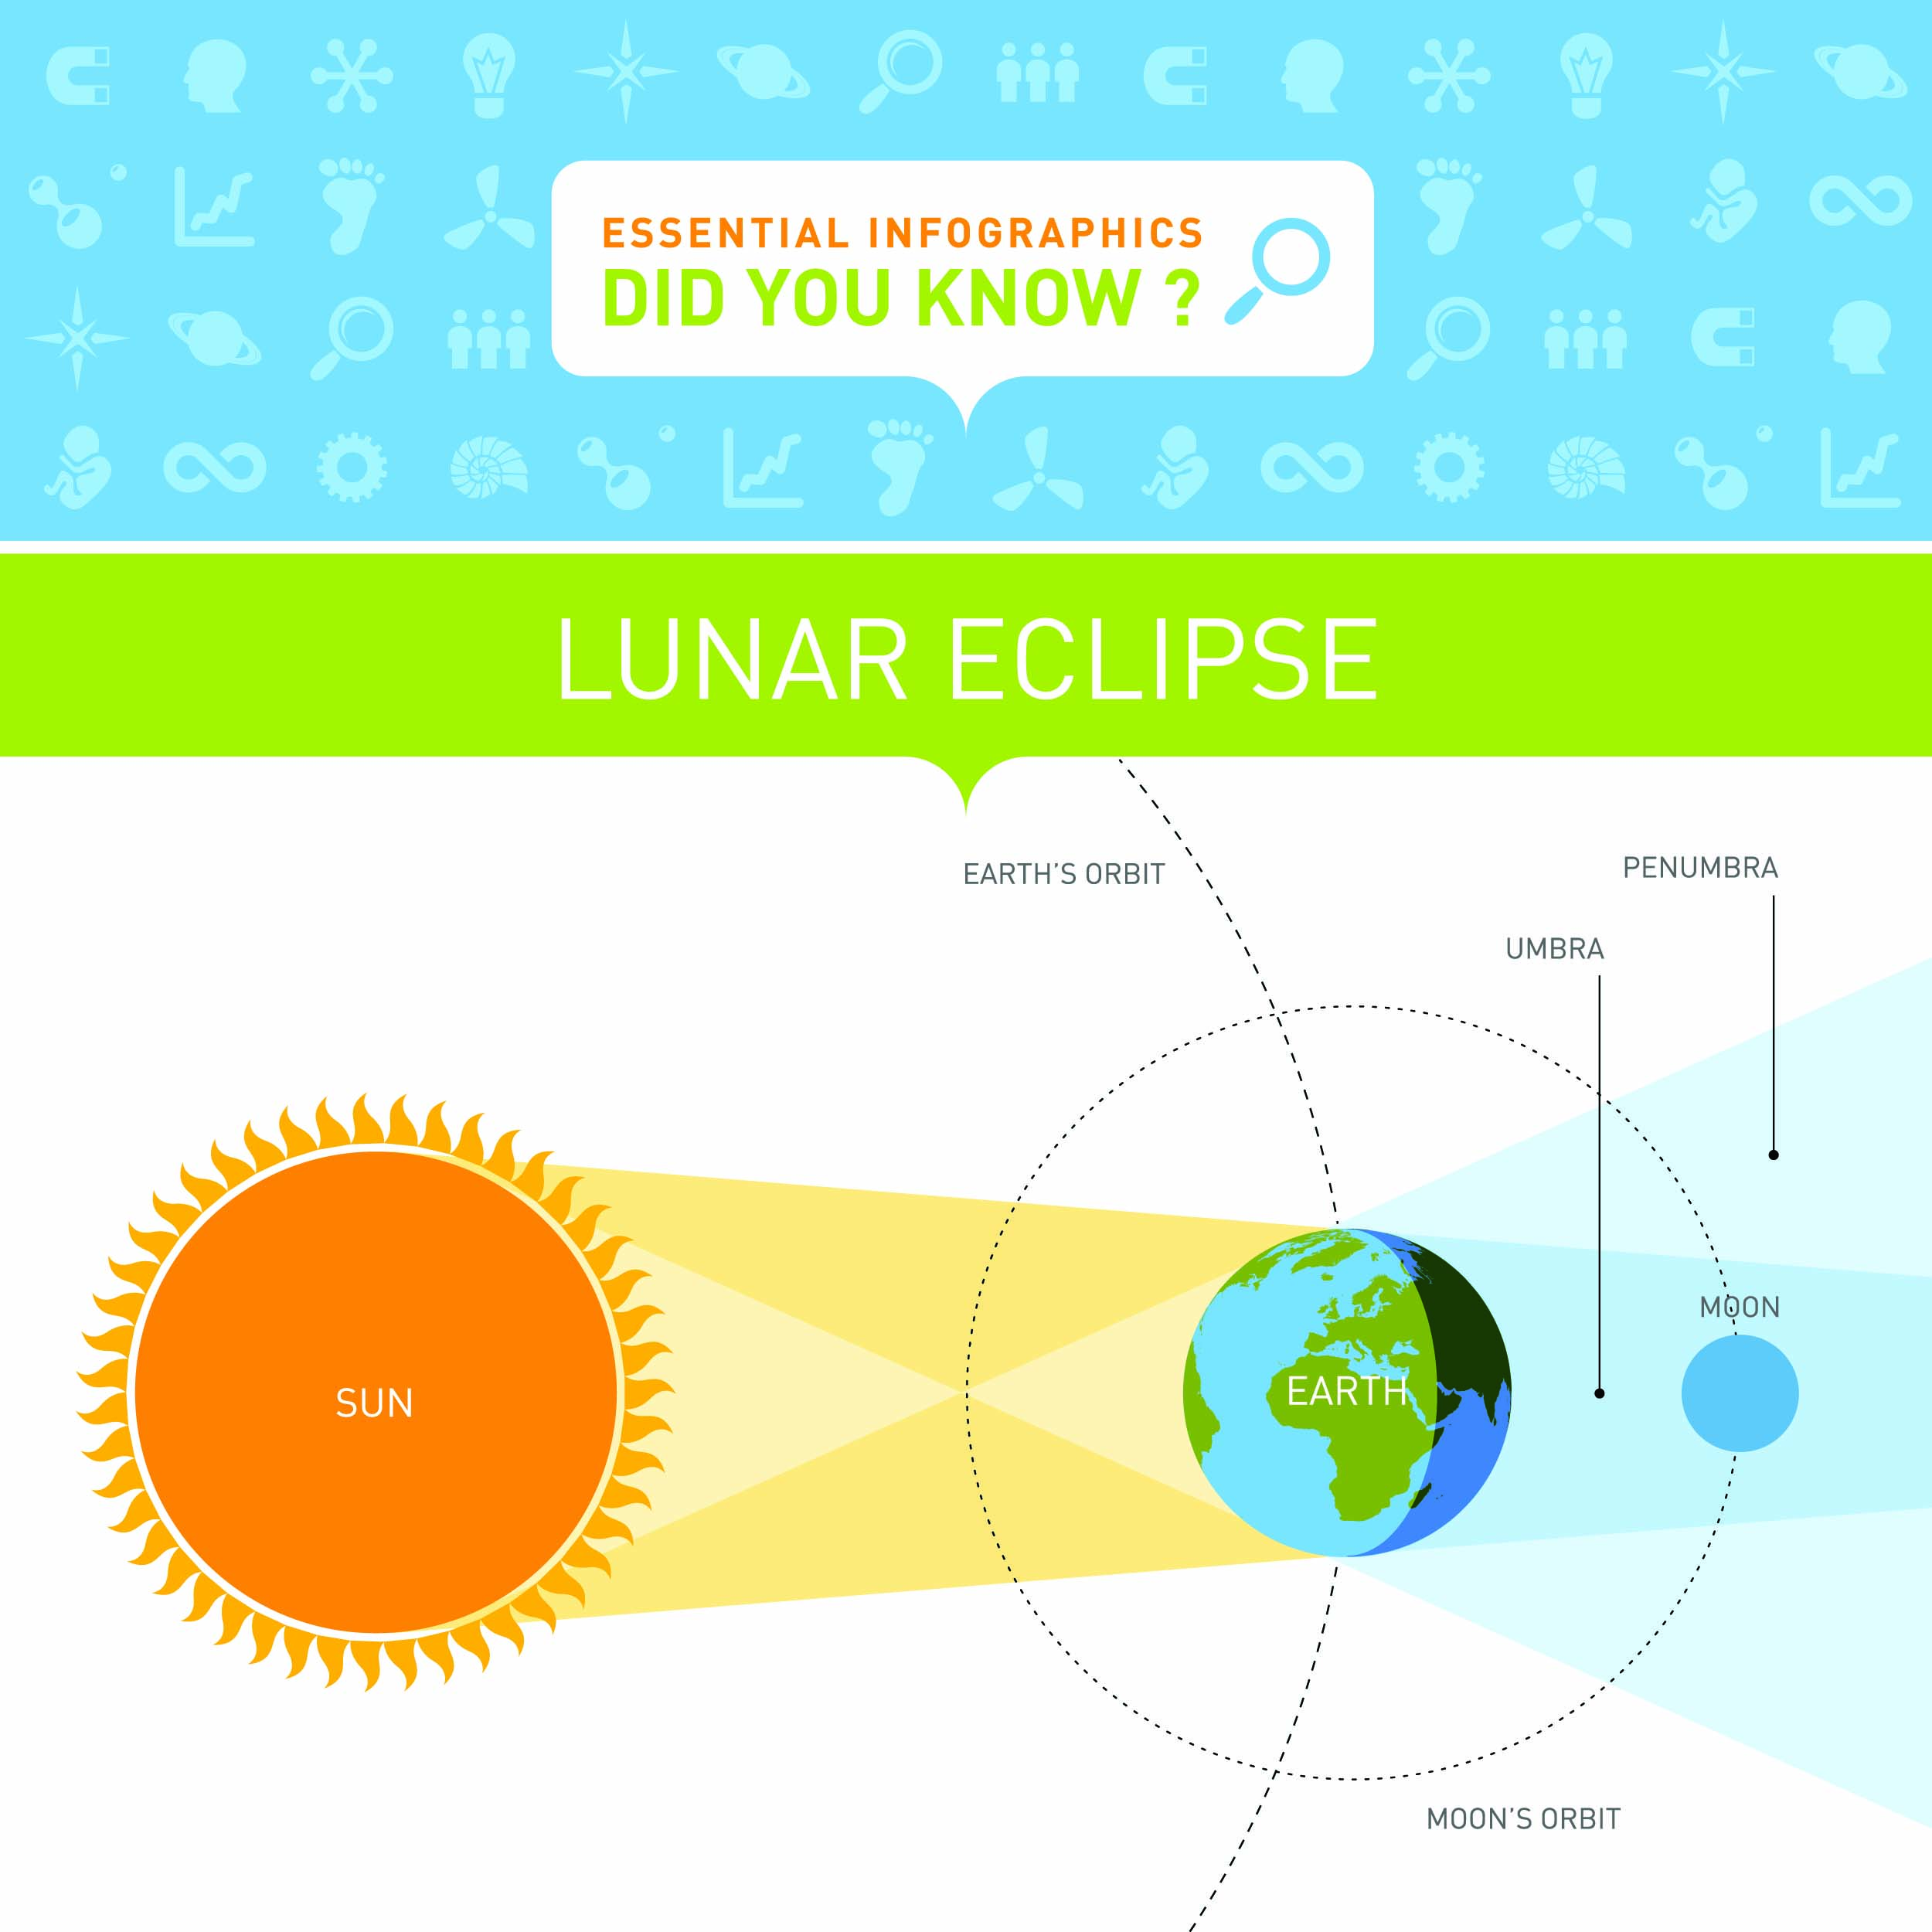

WORD DETECTIVE

5 Word Search

Find the words listed, in the puzzle below.

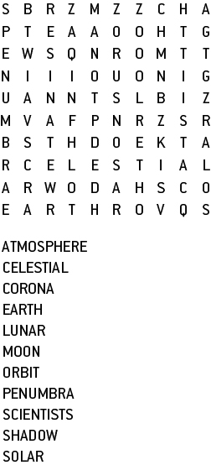

Literacy support worksheet

9.2 The Moon reflects the Sun’s light

Pages 158–159 and 212

Phases of the Moon

1 Below is a diagram showing the phases of the Moon.

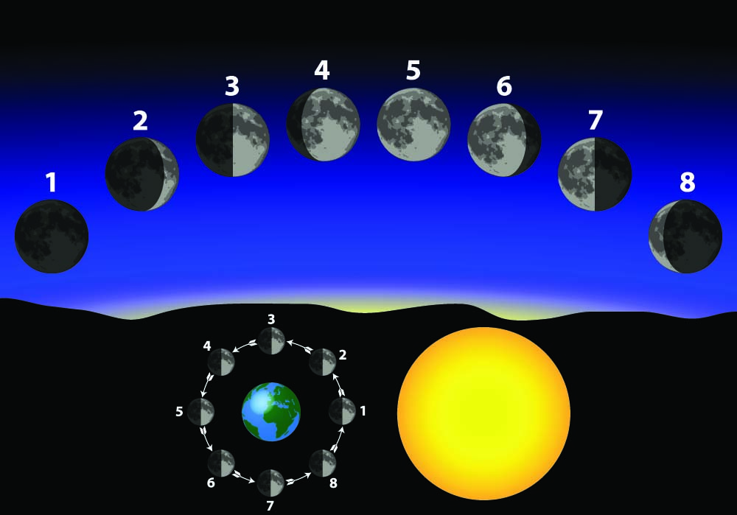

Fill in the table to show the phase of the Moon.

|  |  |
| --- | --- |
| 1 |  |
| 2 |  |
| 3 |  |
| 4 |  |
| 5 |  |
| 6 |  |
| 7 |  |
| 8 |  |

2 a How did Galileo, the first astronomer, observe the Moon?

b What shape is the Moon really? Explain why the Moon sometimes looks different shapes.

3 a When did people first land on the Moon? _____________________________________________

b Who were the first two people on the Moon?

c How did the astronauts move around on the Moon?

WORD DETECTIVE

4 Mumbo-jumbo

a Use the marked letters to find the secret word (e.g. olusntoi = solution).

b Unscramble each of the clue words below to find the message.

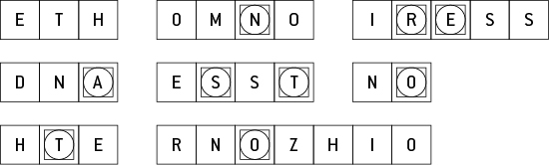

Secret word: __________________________________________________________________________

Message: ____________________________________________________________________________

Literacy support worksheet

9.3 Seasons are caused by the tilt of the Earth

Pages 160–161 and 212

Seasons

1 Below is a diagram showing the Earth’s rotation around the Sun over a year. Fill in the boxes to explain what happens to deciduous trees (those that lose their leaves) when the Earth is in a different position, for each season in Australia.

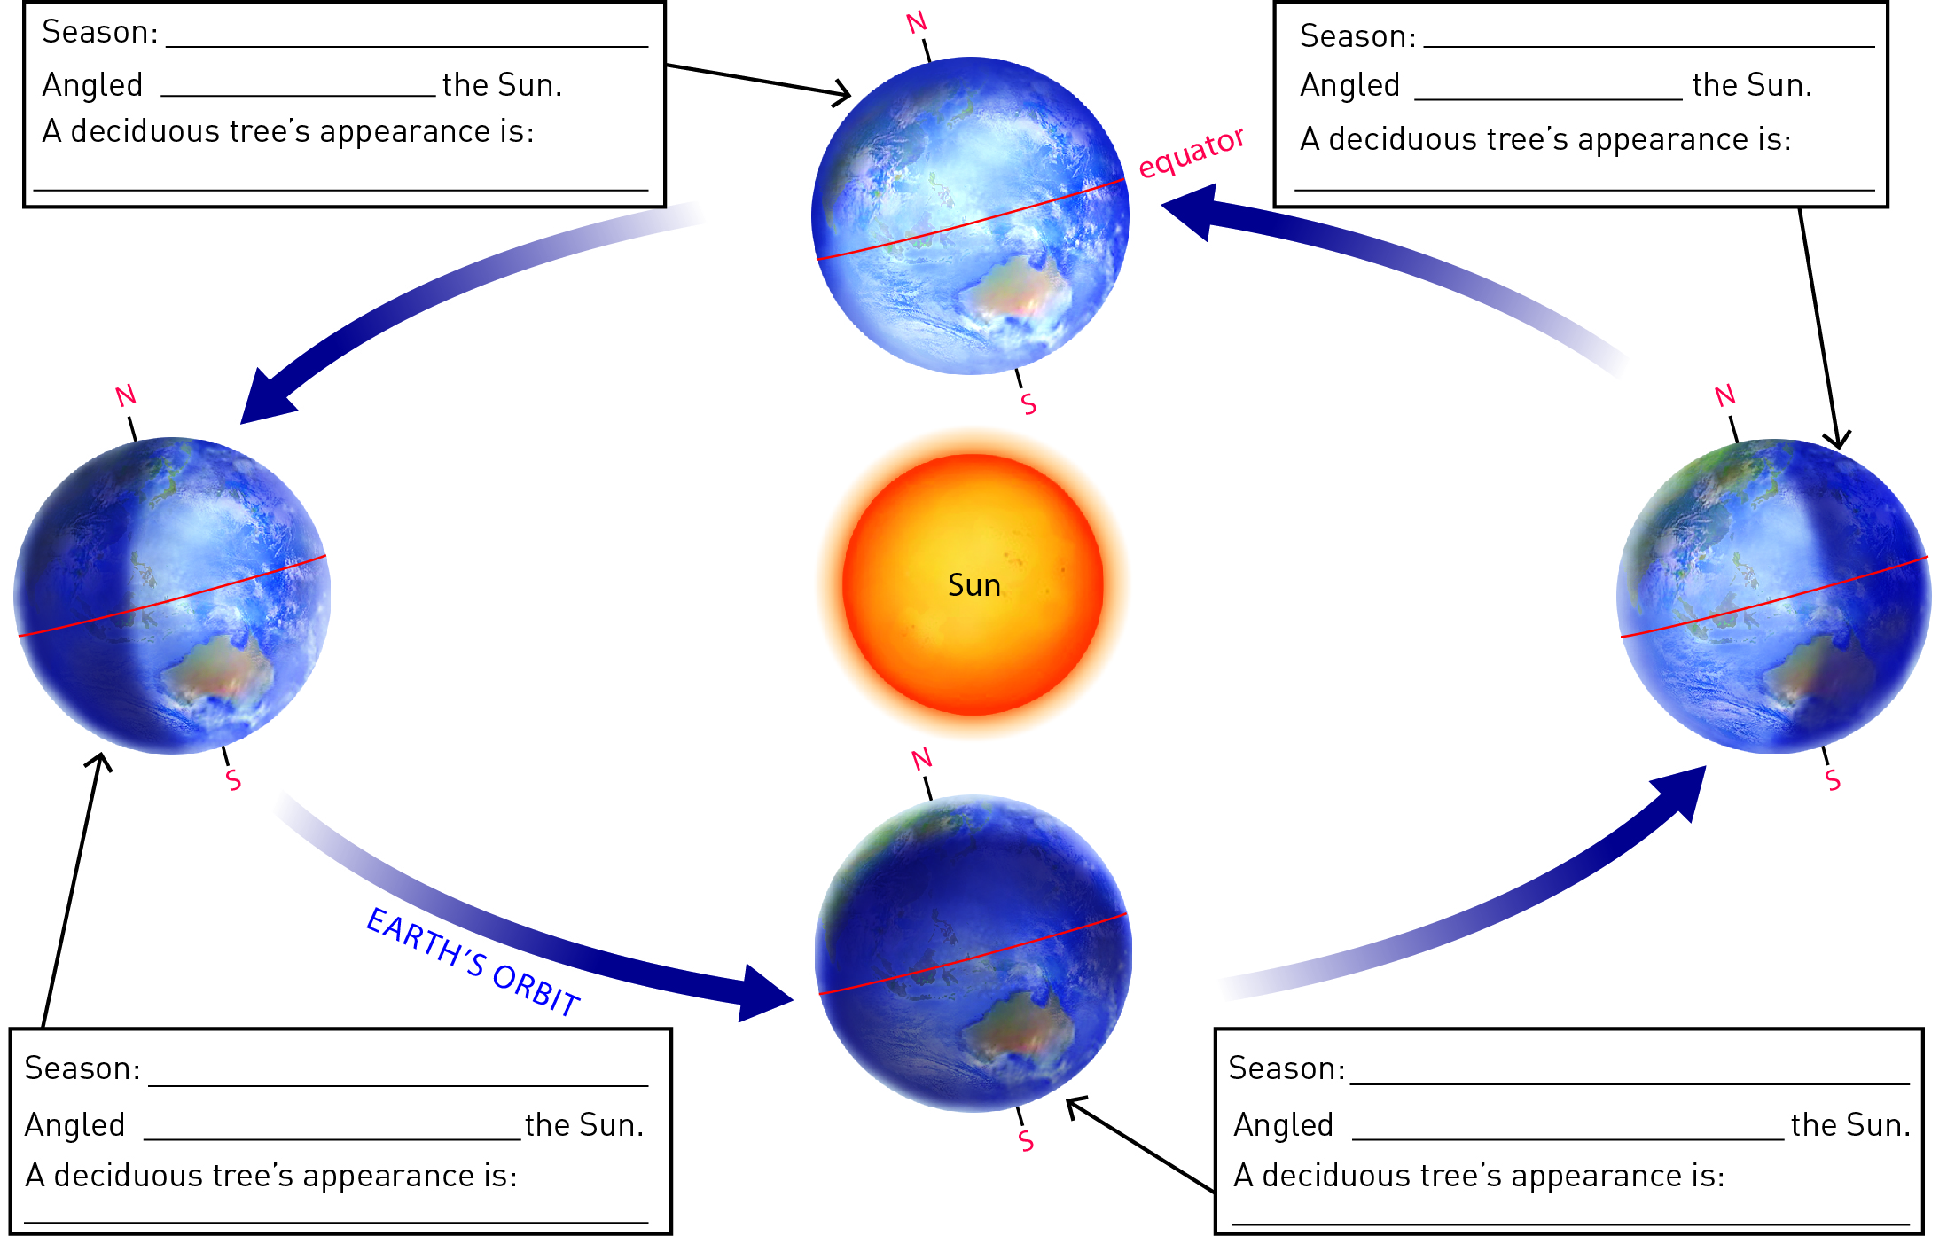

2 What does the tilt of the Earth do?

3 Fill in the boxes in the diagram below to explain what is happening in the Northern Hemisphere in the United States of America when the Earth is in the different positions.



WORD DETECTIVE

4 Word search

Find as many words as possible in the puzzle below.

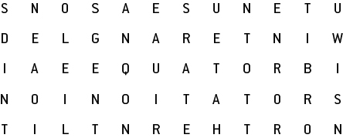

Literacy support worksheet

9.4 Astronomers explore space

Pages 162–163

Astronomy

1 Describe the ways that ancient astronomers used their observations of the stars, Sun and Moon to help them.

a The movement of the planets helped them to:

b The positions of the stars helped them to:

2 What information can be gathered by using telescopes?

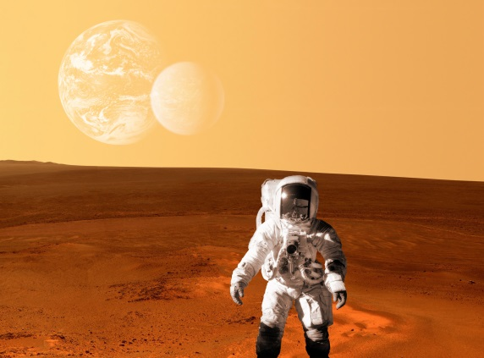3 The image here is of an astronaut exploring the surface of Mars. In the background you can see a moon of Mars and also the planet Earth.

a Is the image real or fake?

b What are some of the factors that helped you reach your conclusion?

WORD DETECTIVE

4 Crossword

Read the clues below and place the correct answers in the crossword boxes.

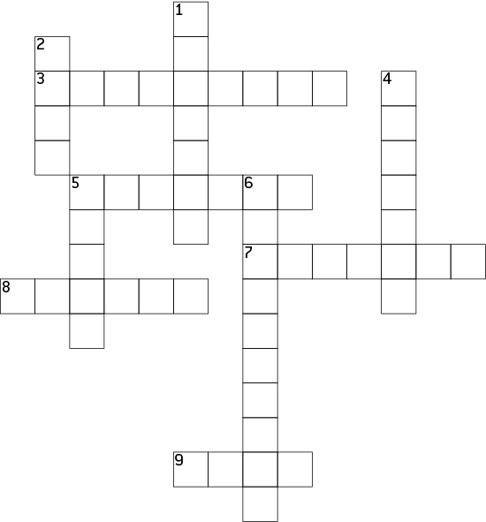

|  |  |
| --- | --- |
| **Across** | **Down** |
| 3 The study of the stars  5 The most common type of telescope used  8 To make things bigger  9 The name of a Mars exploration rover  10 A type of matter that cannot be photographed | 1 The name of the Mars Lander  2 The red planet  4 From a robot  5 To travel around the Earth  6 Made up of gases, surrounding the Earth |